Solution Architecture
Project Design Phase
Date | 15 February 2025
Team ID | SWTID-2026-1074
Project Name | SB Stocks
Team Size | 5
Team Leader | Venkatesh Illa
Team Members | Durga Meghana Kondempudi, Chandrika Narla, Mogali Shyam, Sravani Jagu
Maximum Marks | 4 Marks

SB Stocks — Solution Architecture Diagram
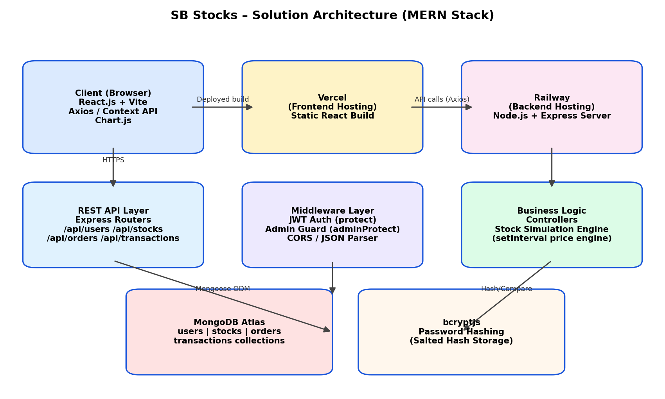
Figure: SB Stocks three-tier MERN architecture — React client on Vercel, Express/Node REST API on Railway, and MongoDB Atlas for persistence, secured end-to-end with JWT and bcrypt.

Architecture Summary
The client is a React single-page application that talks to the Express REST API purely over HTTPS/JSON using Axios. All protected routes are guarded by a JWT-verification middleware (protect) and an additional role check (adminProtect) for admin-only endpoints. Mongoose schemas (users, stocks, orders, transactions) model the data in MongoDB Atlas. An in-memory background job (startStockSimulation) mutates a shared market-data array every 4 seconds to simulate realistic price movement without needing a paid market-data subscription.

